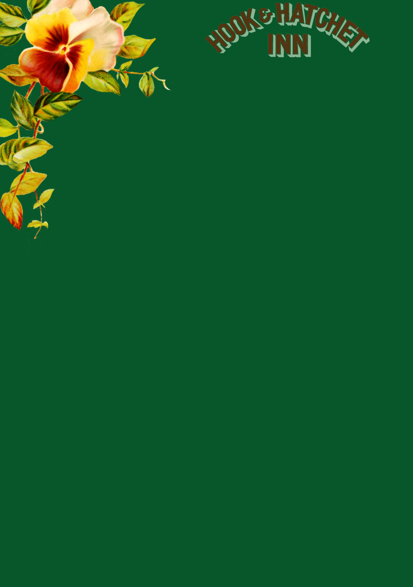

**Marinated Olives** **£3.00**

**Warm Baguette** with Oils and Balsamic **£4.00**

**Nachos** served with Cheese, Jalapenos, Peppers, Black Olives, Spring Onions & Salsa Sauce and Sour Cream **£5.00**

**Haloumi Fries** with sweet chilli dip **£4.50**

**Pil Pil Prawns**, prawns cooked in chilli, garlic and paprika **£7.50**

**Hot Wings** served with garlic mayo **£5.50**

**Homemade Soup of the day** served with a Slice of Bread **£4.00**

**Chicken Satay** with Malaysian Sauce and Jasmine Rice (GF) **£6.20**

**Creamy Garlic Mushrooms** served on Toasted Ciabatta (V/GF option) **£5.50**

**Prawns and Smoked Salmon** with a Marie Rose Sauce **£7.50**

**Camembert –** Topped with Garlic, Olive Oil and served with Chutney and Crispy Bread **£9.50**

**Seafood –** Seafood salad, smoked salmon, Chipirones,2 Mediterranean Prawns **£15.90**

**Mixed Platter –** Chicken Strips, Garlic Bread, Tempura Prawns, Breaded Garlic Mushrooms, Sweet Chilli Dip & Garlic Mayo **£13.90**

(All served with Chunky Chips & Homemade Coleslaw)

**8oz Homemade Beef Burger** with lettuce, tomato and Burger relish **£12.50**

**Breast of Chicken** with lettuce, tomato and Garlic mayo **£12.00**

**Moving Mountain Vegan Burger** with lettuce, tomato and vegan Mayo **£10.50**

**Homemade Lamb Mint Burger** with lettuce, tomato and mayo **£13.00**

**Add Toppings £1.00 Each:**

Cheese / Mushrooms / Bacon / Blue Cheese / Jalapeno Chilli / Onion Rings / Brie

Please make a note of your table number, order and pay at the bar.

Church Road, Hucking, Maidstone, ME17 1QT. 01622 880272. [www.hookandhatchetpub.co.uk](http://www.hookandhatchetpub.co.uk)

Before you order your food and drink, please inform a member of staff if you have a food allergy or intolerance.

All our food is freshly cooked so please allow extra time in busy periods.





**Homemade Meat Lasagne** served with Garlic Bread and Side Salad **£9.90**

**Homemade Vegetable Lasagne** served with Garlic Bread and Side Salad (V/VG option) **£9.90**

**Ravioli** stuffed with Ricotta and Spinach in Aurora Sauce **£9.50**

**Homemade Chicken and Mushroom Stroganoff** with Rice and Green Beans **£10.90**

**Mushroom Stroganoff** with Rice and Green Beans **£8.90**

**Homemade Pie of the day** with Chunky Chips/Mash Potatoes, Garden Peas & Onion Gravy **£11.90**

**Local Award-Winning Sausages** with Mash, Garden Peas & Onion Gravy **£9.00**

**Honey Roast Ham** served with 2 Eggs, Chips andMustard Mayo **£8.50**

**Traditional Ploughman’s** Cheese and Ham **£9.50**

**Sirloin** with Chips, Peas and Roasted Tomato **£16.50**

**Add a sauce** for **£1.50**

Peppercorn / Garlic butter / Blue Cheese / Chimichurri

**Butterflied chicken Breast** in Cajun Spices served with Spiced Couscous **£10.90**

**Scampi** with Chips & Peas **£8.90**

**Fish and Chips** with Mushy Peas **£11.50**

**Cherry Tomatoes, Spinach, Rocket, Pepper, Cucumber** served with Couscous and a French Dressing £**5.50**

**ADD:**

Chicken £4.50 / Tuna £4.50 / Ham £4.00 / Cheese £4.00 / Prawn £6.00

North Atlantic Prawns with Marie Rose Sauce £7.00

Chicken, Bacon and Mayonnaise £6.50

Goats Cheese, Roasted Red Pepper and Pesto £5.00

Bacon, Brie and Cranberry £6.50

Fish Finger and Tartar Sauce £6.90

Smoked Salmon and Cream Cheese £6.00

Gammon Ham and Branston Pickle £4.50

Mature Cheddar and Onion £4.50

Cheese and Ham £5.00

Finest Wild Tuna with Mayonnaise £5.50

Cheesy Chips £3.50

Chips £2.50

French Fries £2.00

Garlic Bread £3.00

Cheesy Garlic Bread £4.00

Onion Rings £2.00

Mushrooms £3.00

Green salad £3.00

Church Road, Hucking, Maidstone, ME17 1QT. 01622 880272. [www.hookandhatchetpub.co.uk](http://www.hookandhatchetpub.co.uk)

Before you order your food and drink, please inform a member of staff if you have a food allergy or intolerance.

All our food is freshly cooked so please allow extra time in busy periods.

