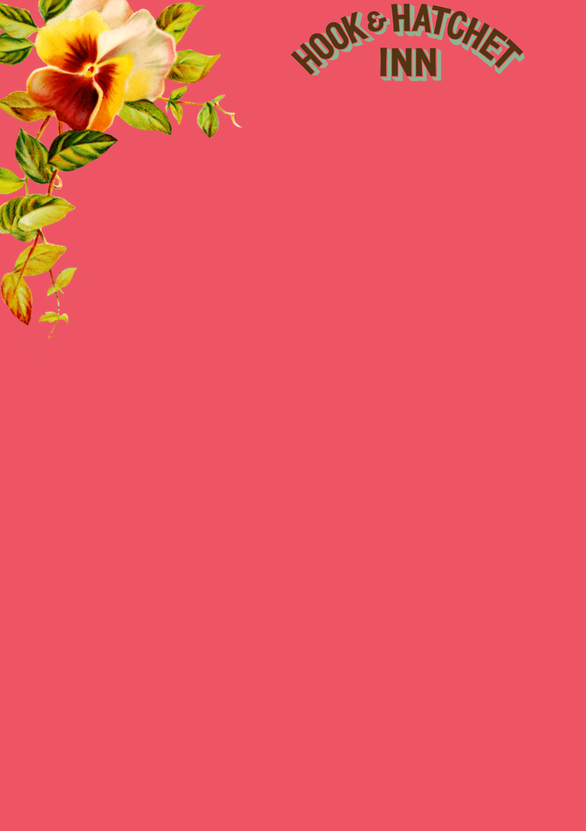

**BIG BREAKFAST**

2 Bacon, 2 Sausages, Beans, Mushrooms, 2 Hash Brown, 2 Fried Eggs & Toasted Bloomer Bread **£6.90**

**HALF BREAKFAST**

1 Bacon, 1 Sausage, Beans, Mushrooms, 1 Hash Brown, 1 Fried Egg & Toasted Bloomer Bread **£5.50**

**VEGGIE BREAKFAST**

2 Veggie Sausages, 2 Eggs, Mushrooms, Beans, 2 Hash Browns & Toasted Bloomer Bread **£6.00**

**SMOKED SALMON**

Smoked Salmon and Scrambled Eggs with Toasted Bloomer Bread **£7.10**

**OMELETTE**

Three Egg Omelette **£4.50** Ham/Bacon/Mushrooms/Cheese **£1.00 Extra Each**

**EGGS ON TOAST**

Eggs on Toasted Bloomer Bread

2 Poached/2 Fried/Scrambled **£4.50**

**TOAST**

Toasted Bloomer Bread served with Butter & Preserves

One Portion – Two Slices **£2.90**

**BREAKFAST WRAPS OR SANDWICH BREAD**

CHOOSE FROM THE FOLLOWING:

Sausage, Bacon, Fried Egg, Mushrooms

1 Item **£3.90** 2 Items **£4.40** 3 Items **£4.90** 4 Items **£5.40**

Please make a note of your table number, order and pay at the bar. **Available Saturday from 9am-12pm and Sunday 8am-10:30am**

Church Road, Hucking, Maidstone, ME17 1QT. 01622 880272. [www.hookandhatchetpub.co.uk](http://www.hookandhatchetpub.co.uk)

Before you order your food and drink, please inform a member of staff if you have a food allergy or intolerance.

All our food is freshly cooked so please allow extra time in busy periods.